Demo Pics Banking information System.pdf

1. Page 1 :

Step 1: Enter Your Card Number and PIN Number (if you have any account in bank) and Click on Sign in Button.

Step 2: Otherwise Click on Sign up Button.

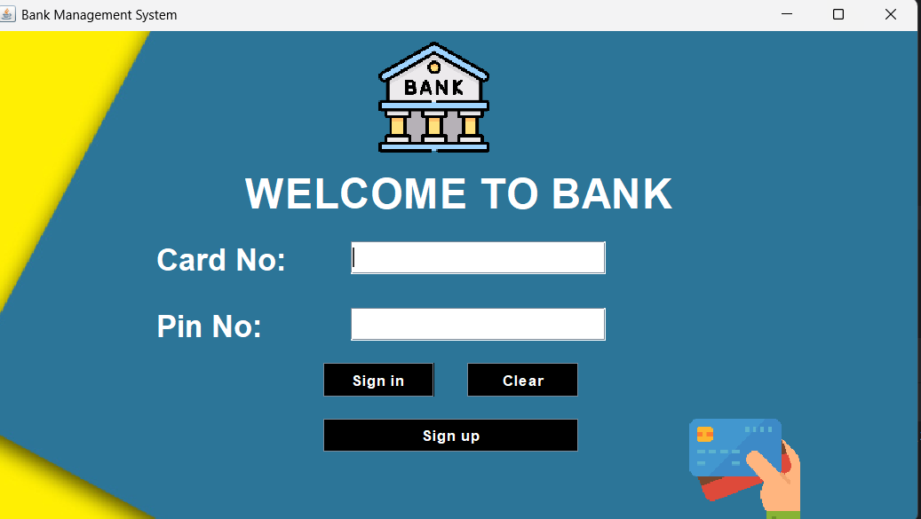

1. Page 2:

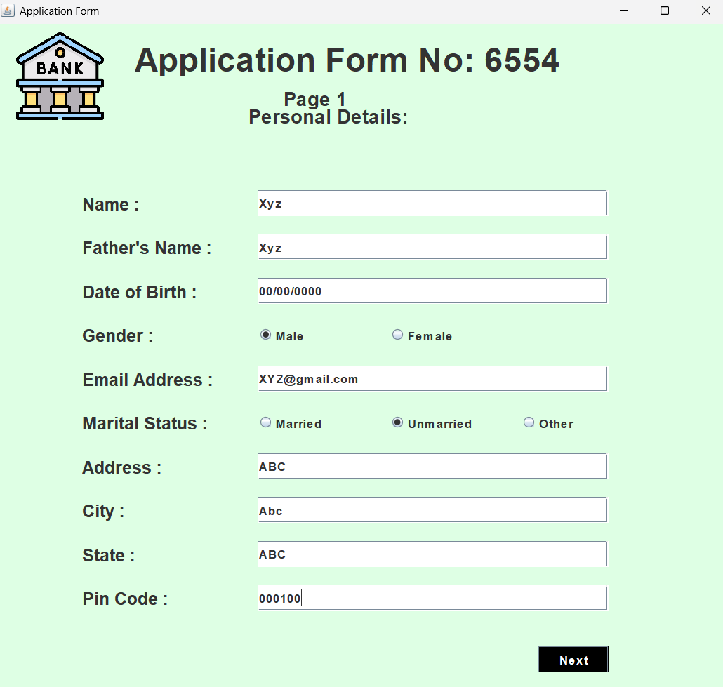 Enter Your Personal Details

1. 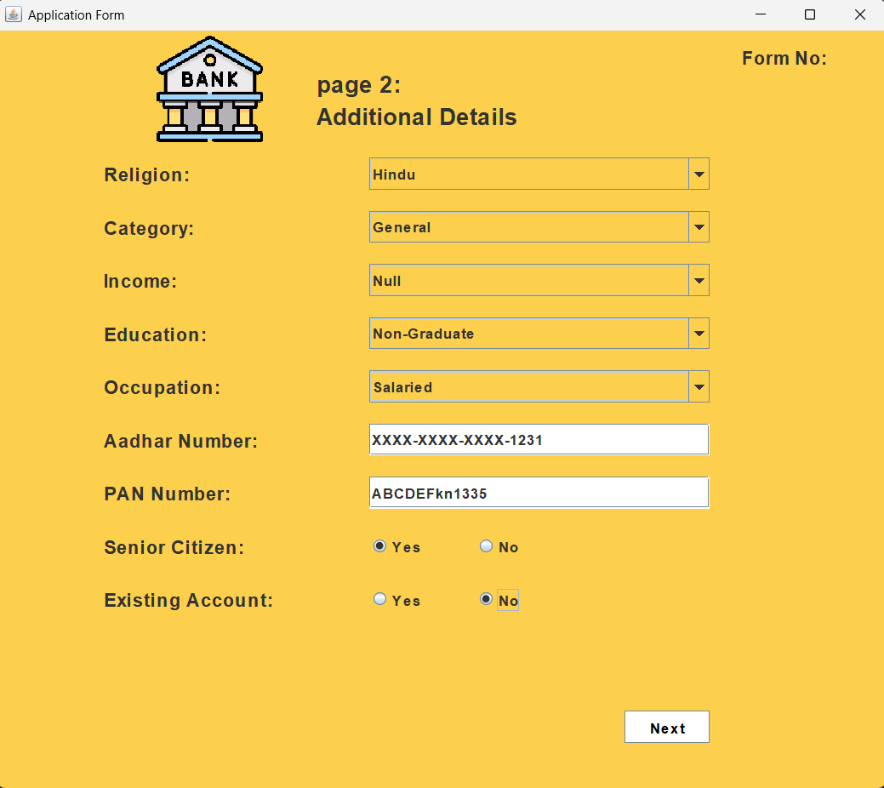Page 3 :

1. Page 4:

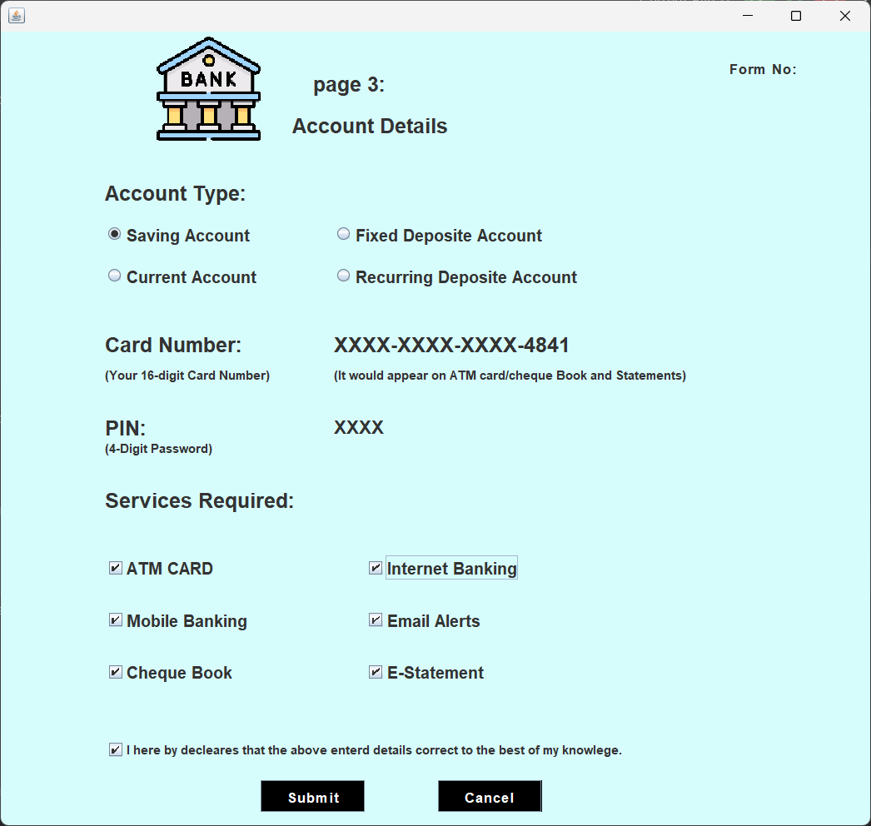Click on Submit Botton:

1. Page 5:

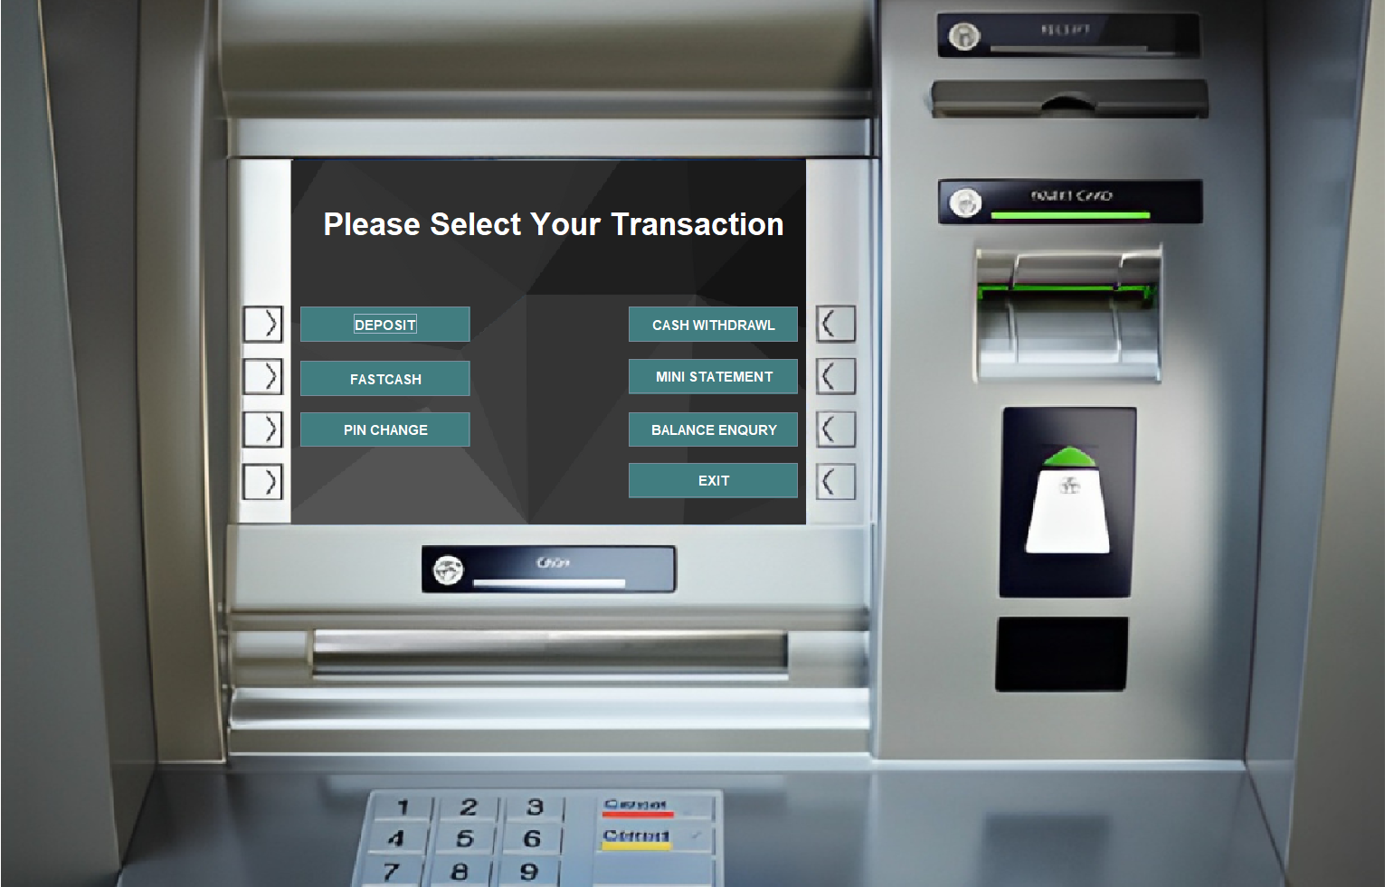This screen is show after the click on Sign in (login page).

1. Page 6:

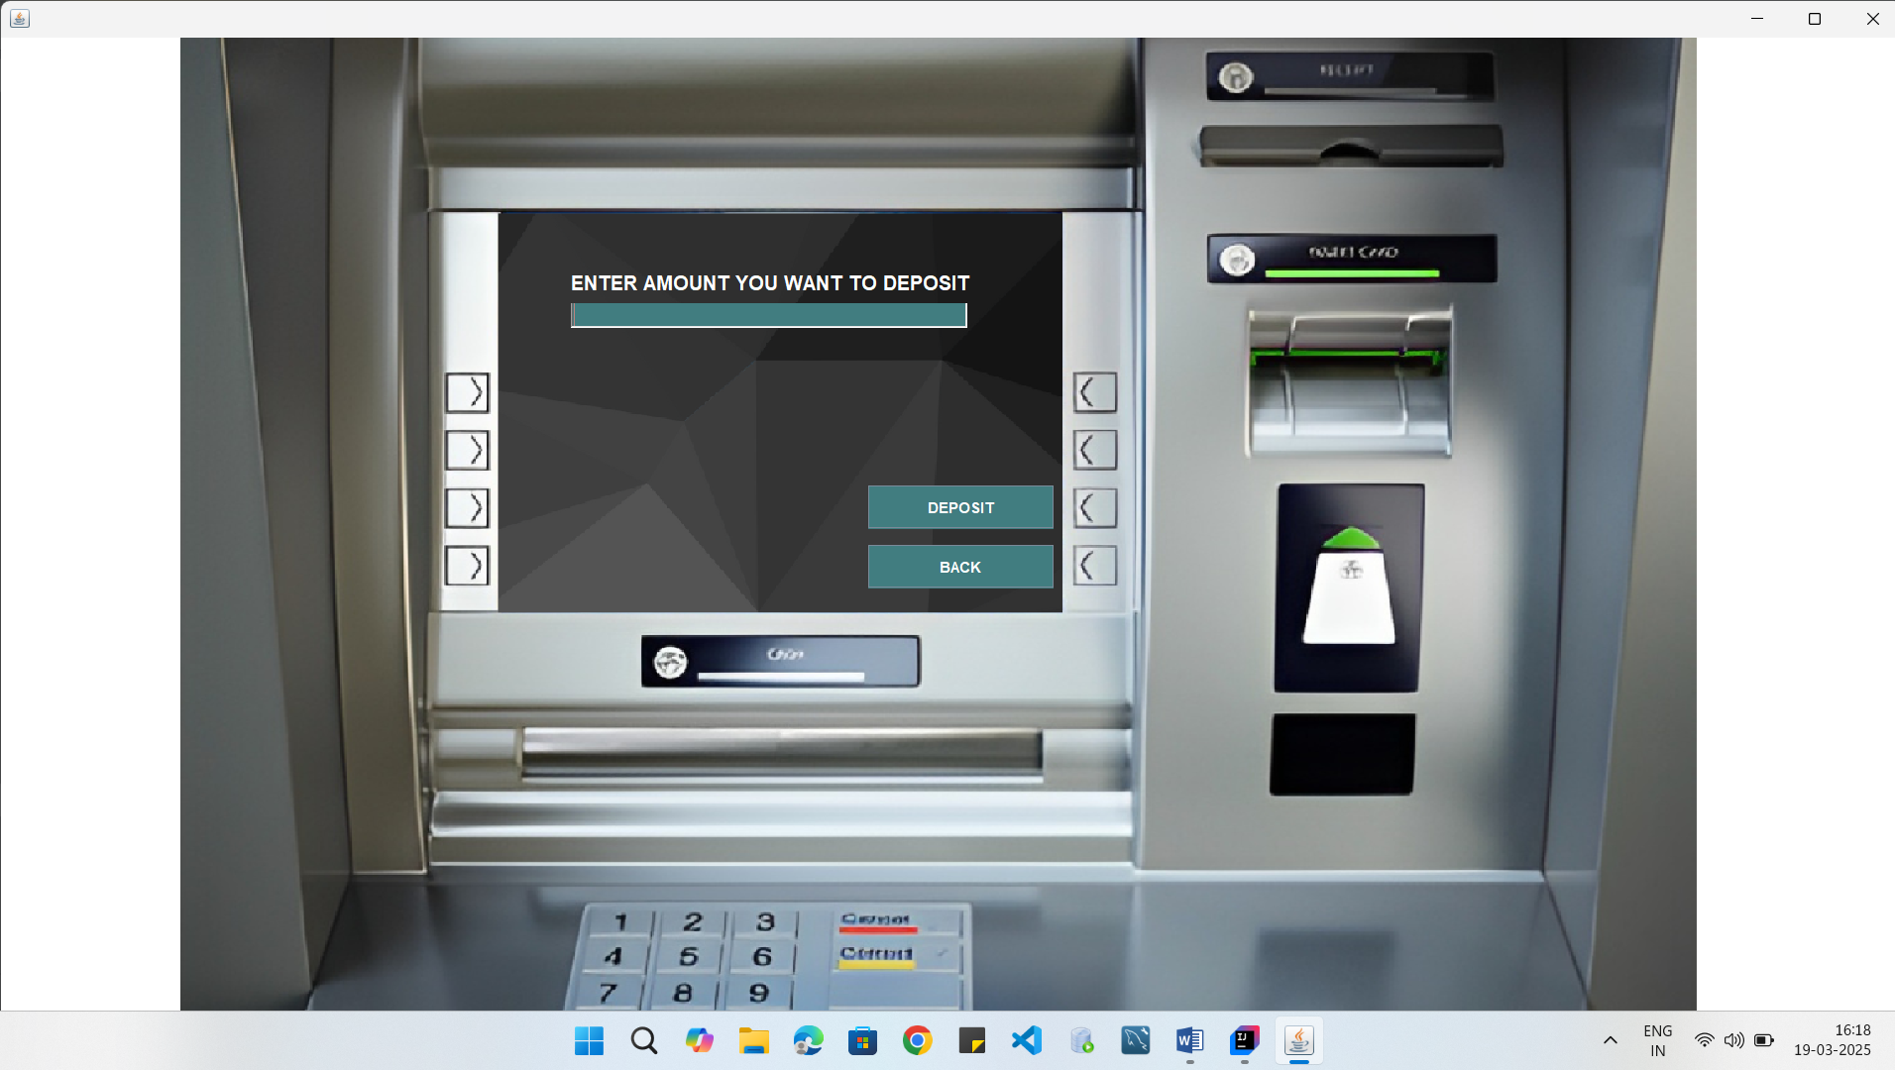This screen is show after Click on Deposit Button:

1. page 7:

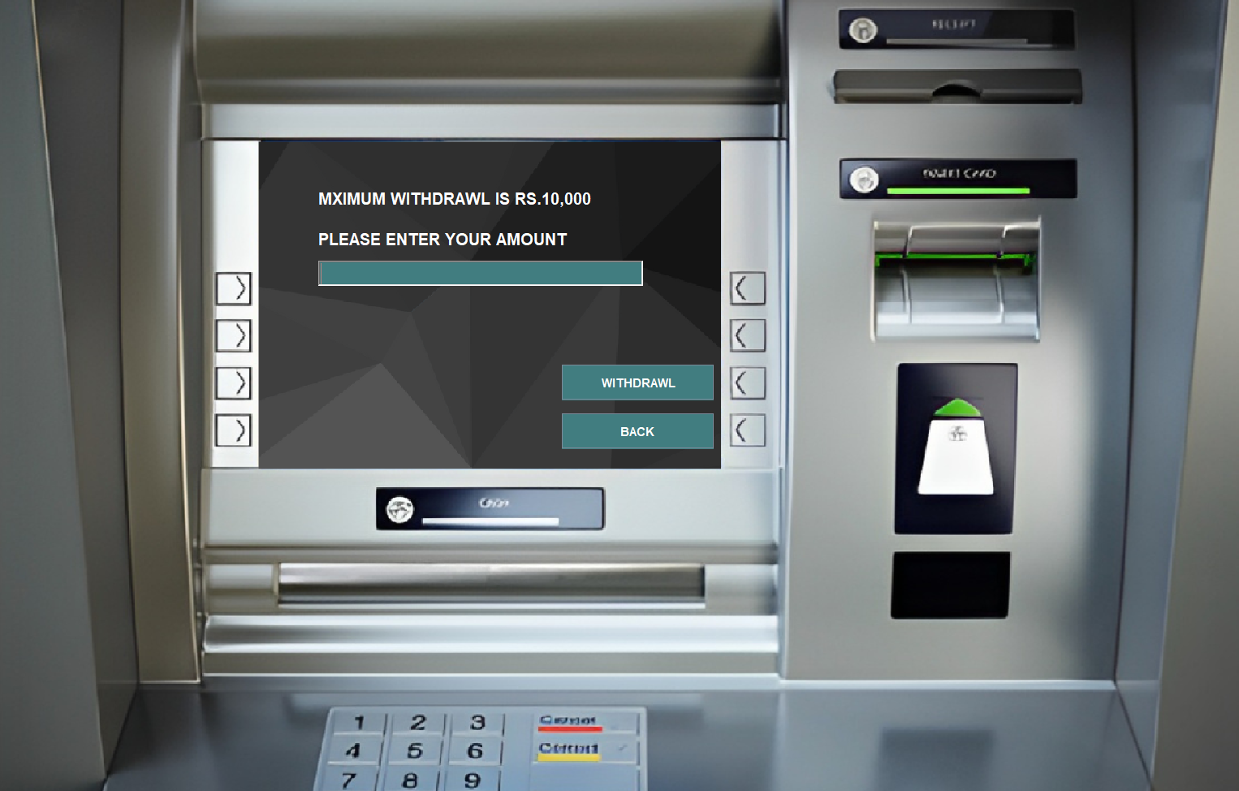This screen is show after Click on Withdrawl Button:

1. page 8:

This screen is show after Click on Balance Enqury Button:

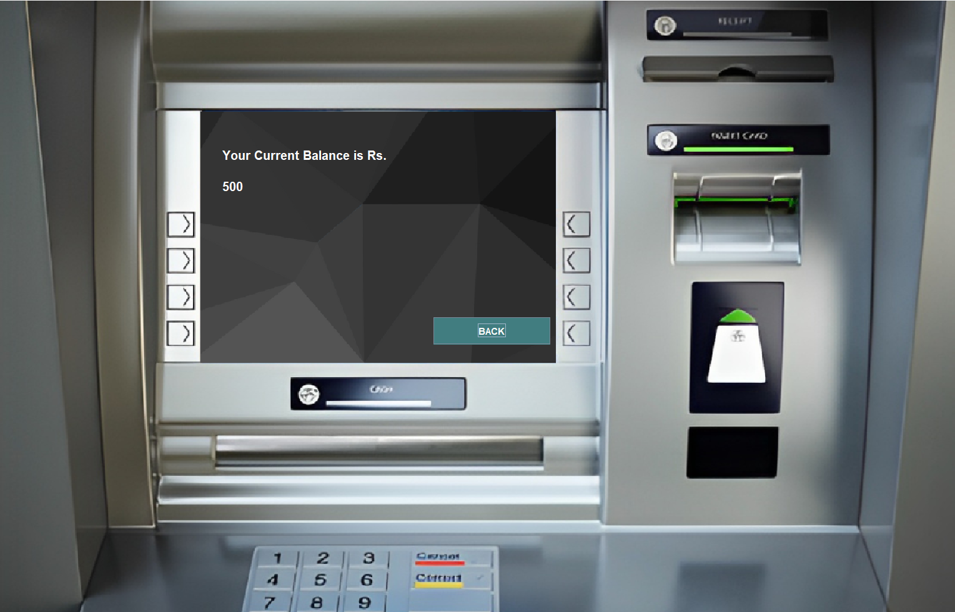

1. page 9:

This screen is show after Click on Mini Statement Button:

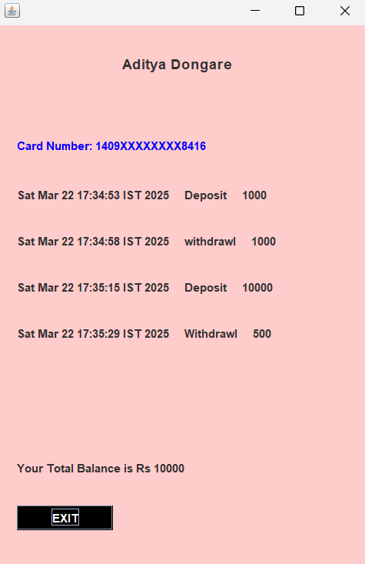

1. 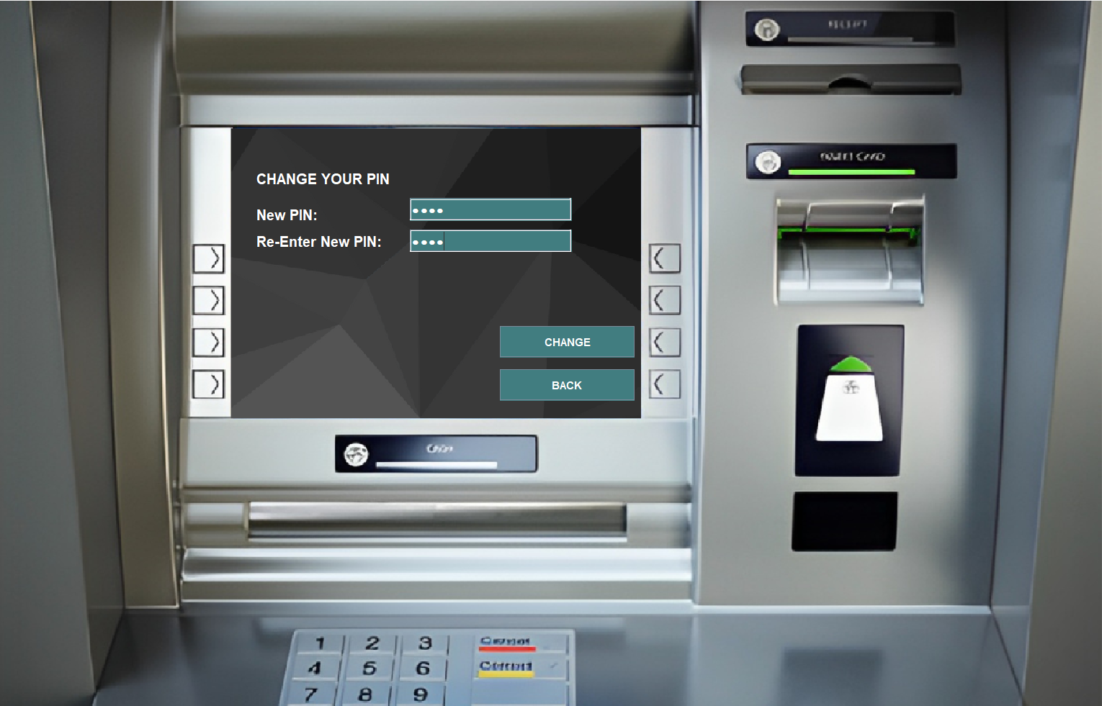page 10:
2. This screen is show after Click on PIN Change Button:
3. Page 11:
4. This screen is show after Click on Fast Cash Button:

